**DEPARTMENT OF COMPUTER TECHNOLOGY**

**ANNA UNIVERSITY, MIT CAMPUS**

**CS6308-JAVA PROGRAMMING**

**Quick Reference**

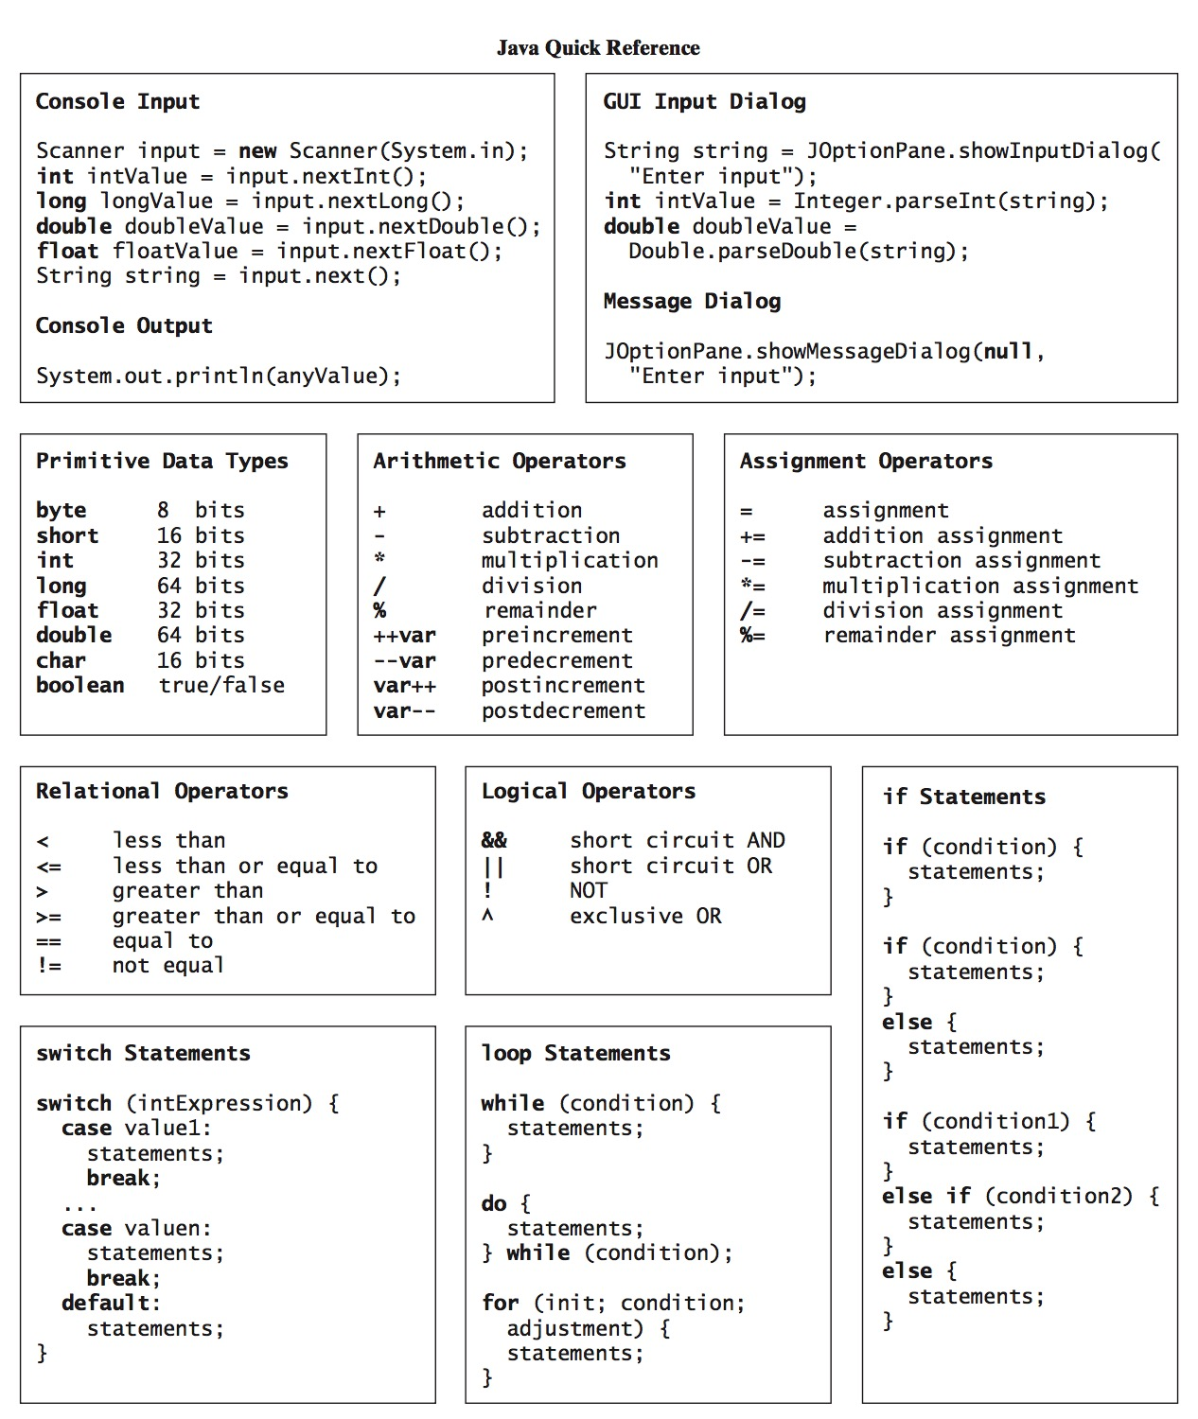

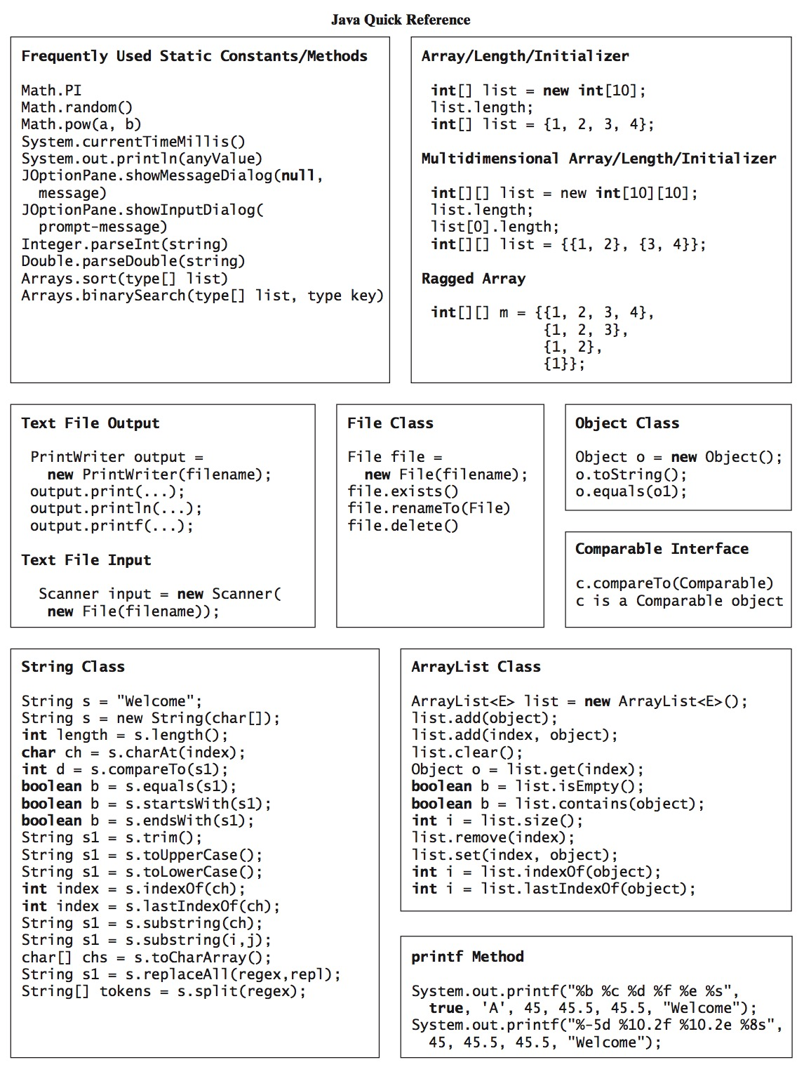

**PRACTICE PROGRAMS-OPERATORS & CONTROL STATEMENTS**

1. Write a java program to check if character is alphabet or digit using **logical operator**

import java.util.*;

public class operators {

    public static void main(String[] args)

    {

char ch = 'a';

   if (ch >= 65 && ch <= 90|| ch >= 97 && ch <= 122)

            System.out.println( ch + " is an alphabet.");

        else if (ch >= 48 && ch <= 57)

            System.out.println(ch + " is a digit.");

        else

            System.out.println(ch + " is a special character.");

    }

}

2. Write a java program to swap two numbers using **bitwise operator.**

Program:

import java.util.Scanner;

public class JavaExample

{

public static void main(String args[])

{

int num1, num2;

Scanner scanner = new Scanner(System.in);

System.out.print("Enter first number:");

num1 = scanner.nextInt();

System.out.print("Enter second number:");

num2 = scanner.nextInt();

/* To make you understand, lets assume I am going

* to enter value of first number as 10 and second

* as 5. Binary equivalent of 10 is 1010 and 5 is

* 0101

*/

//num1 becomes 1111 = 15

num1 = num1 ^ num2;

//num2 becomes 1010 = 10

num2 = num1 ^ num2;

//num1 becomes 0101 = 5

num1 = num1 ^ num2;

scanner.close();

System.out.println("The First number after swapping:"+num1);

System.out.println("The Second number after swapping:"+num2);

}

}

3) Write a java program to find the largest number using **ternary Operator**

Program:

import java.util.Scanner;

public class JavaExample

{

public static void main(String[] args)

{

int num1, num2, num3, result, temp;

/* Scanner is used for getting user input.

* The nextInt() method of scanner reads the

* integer entered by user.

*/

Scanner scanner = new Scanner(System.in);

System.out.println("Enter First Number:");

num1 = scanner.nextInt();

System.out.println("Enter Second Number:");

num2 = scanner.nextInt();

System.out.println("Enter Third Number:");

num3 = scanner.nextInt();

scanner.close();

temp = num1>num2 ? num1:num2;

result = num3>temp ? num3:temp;

System.out.println("Largest Number is:"+result);

}

}

4) A java program to implement logical operators. Get username and password from the user. Check if user-name and password match or not using the logical operators. Compare the user-name and password if both are equal print welcome user .Compare the user-name and password if both are not equal print wrong username and password.

Program:

import java.util.*;

public class operators {

    public static void main(String[] args)

    {

        String x = "Sher";

        String y = "Locked";

        Scanner s = new Scanner(System.in);

        System.out.print("Enter username:");

        String uuid = s.next();

        System.out.print("Enter password:");

        String upwd = s.next();

        // Check if user-name and password match or not.

        if ((uuid.equals(x) && upwd.equals(y))

            || (uuid.equals(y) && upwd.equals(x))) {

            System.out.println("Welcome user.");

        }

        else {

            System.out.println("Wrong uid or password");

        }

    }

}

5) Write a java program for **Bitwise Operators**

Program

public class BitwiseOperatorDemo {

public static void main(String args[]) {

int num1 = 11; /* 11 = 00001011 */

int num2 = 22; /* 22 = 00010110 */

int result = 0;

result = num1 & num2;

System.out.println("num1 & num2: "+result);

result = num1 | num2;

System.out.println("num1 | num2: "+result);

result = num1 ^ num2;

System.out.println("num1 ^ num2: "+result);

result = ~num1;

System.out.println("~num1: "+result);

result = num1 << 2;

System.out.println("num1 << 2: "+result); result = num1 >> 2;

System.out.println("num1 >> 2: "+result);

}

}

**Control Statements:**

1.Write a java program to print Factorial of a number using for loop.

Program:

class FactorialExample{

public static void main(String args[]){

int i,fact=1;

int number=5;//It is the number to calculate factorial

for(i=1;i<=number;i++){

fact=fact*i;

}

System.out.println("Factorial of "+number+" is: "+fact);

}

}

2) Write a java Program to Print Armstrong number.

|  |  |
| --- | --- |
|  |  |
|  |  |
|  |  |
|  |  |
|  |  |
|  |  |
|  |  |

Program.

class ArmstrongExample{

public static void main(String[] args) {

int res=0,d,act;

System.out.println("Enter a number:");

Scanner scanner = new Scanner(System.in);

n=Scanner.nextInt();

act=n;

while(n>0)

{

d=n%10

res=res+(d*d*d)

n=n//10

}

if(act==res)

System.out.println("armstrong number");

else

System.out.println("Not armstrong number");

}

}

3) Write a java program to find the gcd of two numbers.

Program:

import java.util.Scanner;

public class GCD{

public static void main(String[] args) {

int num1, num2;

//Reading the input numbers

Scanner scanner = new Scanner(System.in);

System.out.print("Enter first number:");

num1 = (int)scanner.nextInt();

System.out.print("Enter second number:");

num2 = (int)scanner.nextInt();

//closing the scanner to avoid memory leaks

scanner.close();

while (num1 != num2) {

if(num1 > num2)

num1 = num1 - num2;

else

num2 = num2 - num1;

}

//displaying the result

System.out.printf("GCD of given numbers is: %d", num2);

}

}

4) Write a java program to check whether the given number is prime or composite. **FOR LOOP**

Program:

public class PrimeExample{

public static void main(String args[]){

int i,m=0,flag=0;

int n=3;//it is the number to be checked

m=n/2;

if(n==0||n==1){

System.out.println(n+" is not prime number");

}else{

for(i=2;i<=m;i++){

if(n%i==0){

System.out.println(n+" is not prime number");

flag=1;

break;

}

}

if(flag==0) { System.out.println(n+" is prime number"); }

}//end of else

}

}

5) Write a java program to print floyd’s triangle. **Nested for**

Program:

import java.util.Scanner;

class FloydTriangleExample

{

public static void main(String args[])

{

int rows, number = 1, counter, j;

//To get the user's input

Scanner input = new Scanner(System.in);

System.out.println("Enter the number of rows for floyd's triangle:");

//Copying user input into an integer variable named rows

rows = input.nextInt();

System.out.println("Floyd's triangle");

for ( counter = 1 ; counter <= rows ; counter++ )

{

for ( j = 1 ; j <= counter ; j++ )

{

System.out.print(number+" ");

//Incrementing the number value

number++;

}

//For new line

System.out.println();

}

}

}

6. Write a java program to check whether the given number is Palindrome or not. **While**

Program:

class PalindromeExample{

public static void main(String args[]){

int r,sum=0,temp;

Scanner s=new Scanner(System.in)

n=s.nextInt();

temp=n;

while(n>0){

r=n%10; //getting remainder

sum=(sum*10)+r;

n=n/10;

}

if(temp==sum)

System.out.println("palindrome number ");

else

System.out.println("not palindrome");

}

}

7) Write a java Program for Fibonacci Series using **for loop**

public class JavaExample {

public static void main(String[] args) {

int count = 7, num1 = 0, num2 = 1;

System.out.print("Fibonacci Series of "+count+" numbers:");

for (int i = 1; i <= count; ++i)

{

System.out.print(num1+" ");

int sumOfPrevTwo = num1 + num2;

num1 = num2;

num2 = sumOfPrevTwo;

}

}

}

2. Input a three digit number and check if the digits are in increasing order or not using ternary operators

Expected Output:

Input the number: 123

true

Input the number: 231

false

Solution:

import java. util.*;

public class HelloWorld {

public static void main(String []args) {

Scanner in = new Scanner(System.in);

System.out.print("Input the number: ");

int n = in.nextInt();

int d1= n/100;

n= n%100;

int d2 = n/10;

int d3 = n%10;

boolean b=d1<d2 && d2<d3? true: false;

System.out.println(b);

}

}

3. Write a Java program to divide the two given integers using subtraction operator.

Expected Output:

Input the dividend: 625

Input the divider: 25

Result: 25.0

Flowchart:

Solution:

import java.util.Scanner;

public class Main {

public static void main(String[] args) {

float result = 0;

Scanner in = new Scanner(System.in);

System.out.print("Input the dividend: ");

int dividend = in.nextInt();

System.out.print("Input the divider: ");

int divider = in.nextInt();

if (divider == 0)

System.out.print("Error: Division by zero ");

else

{

while (dividend > divider) {

dividend -= divider;

result++;

}

float decimalPart = (float) dividend / (float) divider;

result += decimalPart;

System.out.println("\nResult: " + result);

}

}

}

5. Write a Java program to convert minutes into a number of years and days

Test Data

Input the number of minutes: 3456789

Expected Output:

3456789 minutes is approximately 6 years and 210 days

Solution:

import java.util.Scanner;

public class Exercise4 {

public static void main(String[] Strings) {

double minutesInYear = 60 * 24 * 365;

Scanner input = new Scanner(System.in);

System.out.print("Input the number of minutes: ");

double min = input.nextDouble();

long years = (long) (min / minutesInYear);

int days = (int) (min / 60 / 24) % 365;

System.out.println((int) min + " minutes is approximately " + years + " years and " + days + " days");

}

}